Business Plan on Organic Pineapple Production
LOGO

Business Name: Organic Pineapple
Address and Location: Durungri, Dungmaed: Pemagatshel
Eastern, Bhutan

Submitted by: ………
(CID No:1020…………..)
Contact No:77225525
Email id choezangsangay@gmail.com
Website:www.organickongtsi.com/

Submitted to (Module Tutor Name, Department, College of Science and Technology as partial fulfillment of internal assessment project proposal)

CONFIDENTIAL AGREEMENT

The undersigned reader acknowledged that the information provided in this business plan is confidential. Therefore, the reader/banker/CSO agrees not to disclose it without the express written permission of the company or promoter.

It is acknowledged by the reader/banker/CSO that the information to be furnished in this business plan is in all respect confidential in nature, other than information that is in the public domain through other means and that any disclosure or use of this confidential information by the reader/banker/CSO may cause serious harm or damage to the company.

Signature:

Name:

Date:

II. TABLE OF CONTENTS

I. CONFIDENTIAL AGREEMENT i
II. TABLE OF CONTENTS ii
III. EXECUTIVE SUMMARY iv
IV. Business Model Canvas iv
V. PROJECT AT A GLANCE 5
VI. PROMOTER’s PROFILE 5
1. Background of the business/company 6
1.1. VMO and Critical Success Factor 6
2. Marketing Plan including market research 7
2.1. The Business environment 7
2.2. Market Analysis 7
2.2.1. Target Market 7
2.2.2. Target Customer Segments 8
2.2.3. Demand analysis 8
2.2.4. Supply analysis 9
2.2.5. Gap analysis 10
2.2.6. Marketing Mix/Strategies (Competitor) 10
2.2.7. Marketing Mix/Strategies (Own Business) 11
2.2.8. Sales Forecast (Income and Revenue Forecasting) 11
2.2.9. Location of Outlet 12
2.2.10. Layout of the Outlet 12
2.3. Assets required for Marketing 12
2.4. Marketing Expenses 13
3. Production and Operations Plan 14
3.1. Production facility location and description 14
3.2. Methods/Processes Involved 14
3.3. Production Schedule 14
3.4. Assets required for production/operations 15
3.4.1. Sources and terms of acquisition of Non-Current Assets 15
3.4.2. Plant capacity and capacity utilization 16
3.5. Raw material requirements and cost 16
3.5.1. Direct material requirements 16
3.5.2. Annual cost of direct materials 16
3.5.3. Sources and availability of direct materials 17
3.6. Direct labour requirements and cost 17
3.6.1. Direct labour requirements 17
3.6.2. Direct Labour Cost 18
3.6.3. Availability of direct labour 18
3.7. Factory Overheads 18
3.7.1. Indirect materials 18
3.7.2. Indirect labour 19
3.7.3. Other indirect costs 19
3.7.4. Total factory overhead costs 19
3.8. Total Production cost and unit production cost 20
4. Organization and Management Plan 21
4.1. Form of business 21
4.2. Business Name and Logo 21
4.3. Capability profile of project proponents 21
4.4. Organizational structure and types 21
4.4.1. Description of key position and responsibility 21
4.4.2. Recruitment, selection and training of staff 22
4.5. Cost of personnel for administration 22
4.6. Assets required for office administration 22
4.7. Pre-operating activities and expenses 23
4.8. Organization and Management expenses 24
5. Financial Plan 25
5.1. Total project cost 25
5.2. Financing Plan 26
5.2.1. Security for Loan 26
5.2.2. Loan Repayment and interest calculation 26
5.2.3. Loan Repayment Schedule 26
5.3. Projected Cost Sheet 26
5.4. Projected Statement of Comprehensive Income 27
5.5. Projected Statement of Cash Flow 27
5.6. Projected Statement of Financial Position 28
5.7. Financial Performance Metrices 29
9.1 Financial assumptions 35
6. Bibliography 36
7. Annexure 36
7.1. Depreciation Schedule 36
7.2. Contracts or agreements 38
7.3. Lagthram 38
7.4. Other Evident Documents 38

III. EXECUTIVE SUMMARY
Brief Description of the Business
[What will be the name of your business? What products will it produce?]
Brief Profile of the Entrepreneur
[Briefly describe your background, experience and future plans. If others will be involved in managing the business, give details of them too.]
…………….

Summary of the Marketing Plan
[Briefly describe your target groups and the strategies you will adopt.]
…………….

Summary of the Production and Technical Plan
[Briefly describe the production process and the technology to be used.]
…………….

Summary of Organization and Management Plan
[Briefly describe the form of business and how you will be organizing it.]

…………….

Summary of the Financial Plan
[Briefly indicate the total investment cost, the financing plan, projected profits and other financial highlights of the business.]

Conclusion of the Project
[Briefly state the socio-economic benefits, which would arise by setting up the proposed business.]

IV. Business Model Canvas

Key Partners  Supporting agencies:  - Dzongkhag Agriculture sector,  - RNR sector,  - Gewog office  Supplier:  - Middleman,  - Schools/Institutions, | Key Activities  - Land development,  - Farm management  - Fencing of orchard  - Plantation,  - Product harvest  - Marketing | Value Proposition  - Organic fruits,  - Quality & sizing  - Large scale production (5 acres) |  | Customer Relationships  - Credit system,  - Promotional sale,  - Gift package | Customer Segments  - BAIL,  - Nearby retailers & businessman,  - Schools, colleges & institutions
 | Key Resources  - Farmland,  - Machineries & tools,  - Finance |  |  | Channels  - Sale in farm,  - Sale at Factory  - Home delivery
Cost Structure  - Daily wage system for labour,  - Cost for machinery & tools,  - Transportation charges,  - Raw materials cost (water pipe, hand tools & chain link) |  |  | Revenue Streams  - Selling of Fruits  - Selling of Saplings/Seedlings  - Running of Wholesale shop,  - Revenue through selling of Farm Yard manure/Green manure

V. PROJECT AT A GLANCE
Project name | Duu-gri Kongtsi Farm
Project type | Sole proprietorship
Project raw material requirement | - Farm power tiller,  - Chain link/electric fencing,  - Water pipe, sintax/barrel  - Hand tools/machineries
Project activity
Project final product | Pineapple (fruits)
Project product sale
Project product value addition
Project installed capacity
Project power requirement
Project factory area requirement | 5 acres of farmland
Project target area for raw materials
Project proposed location | Durungri, Dungmaed, Pemagashel
Project proposed ownership
Project forecasted sales
Project ROI
Project BEP
Project Total Cost
a. Debt
b. Equity
Project foreign exchange
a. Capital
b. Recurrent
Project source of loan
Project manpower requirement
Project environment impact
Project implementation timeline
Project feasibility

VI. PROMOTER’s PROFILE

Name of the founders | Sangay
Education qualification | B.Sc Sustainable Development
DOB | 13-05-1992
CID no.
Contact no.
E-mail ID
Experience
Training
Skills | PR Development
Current address | Samdrup Jongkhar
Permanent address | Pemagatshel

Background of the business/company
Pineapple is one of the fruits grown in the country as a source of income generation after government introduction of National Organic Flagship program in the country. From then, an effort has been taken pertinent to organic agriculture production and the cultivation of pineapple is one that has gained momentum due to its domestic market demand. Technically, pineapple is easy to grow and required less hard work. has lots of health benefit besides the environmental impact. World Health Organization (WHO) and Food and Agriculture Organization (FAO) advocates that pineapple is source of fiber in the diet and increase dietary fiber intake significantly reduces low-density lipoprotein (LDL) cholesterol, triglyceride levels, systolic blood pressure and thereby prevent non-communicable diseases. It’s also an environmental friendly and climate resilient cash crop.

According to Agriculture Survey report 2021, about 128.19 MT of pineapple were harvested and generated income by our farmers. From the total production of 128.19 MT, Pemagatshel Dzongkhag has accorded the highest pineapple production of 41.20 MT in 2021 after many households has started picking up the mass cultivation recently. After launching of Bhutan Agro Industry Limited (BAIL) in Lingmethang and fully given with market assurance through contractual farming, more farmers have now started to expand production. The Department of Agriculture, MoAF through ARDC and Dzongkhags in partnership with CARLEP - IFAD project, Wengkhar, farmers were supported with necessary planting materials in order to maintain the sustainable linkage between producers and market. Fallow land reversion, production enhancement, quality improvement and income are expected to be enhanced.

VMO and Critical Success Factor
- Vision:
Self-reliance in production of organic pineapple and enhancement of socio-economic wellbeing of the rural residents through improved good agriculture practices.

- Mission:
Enhancement of sustainable cash crop productivity in the region through organized & improved production technologies, value chain development and long-term market linkage between producers and end users.

- Objectives
The specific objectives of venturing into this business are:
- To revive the fellow land into productive cultivable agriculture farmland;
- To enhance and strengthen local economy through generation of cash income;
- To lead rural residents with live example to take up large scale production of organic pineapple as source of viable career opportunities.

- Key to Success- 3 lines (based on nature of business)

Marketing Plan including market research

The Business environment
  - STEEPLE
For an entrepreneur to establish a business, it’s important to understand the business environment. For the selected business idea/projects, students must conduct STEEPLE analysis (See environmental scanning under Unit III).

  - SWOT analysis
While STEEPLE provide a view of the external business environment, SWOT enables entrepreneurs to understand the internal/micro environment.

Table 2: SWOT analysis
Sample SWOT analysis for Dragon Clothing
Strengths | Low cost compared to competitors, more readily available, durability, more colour choices
Weakness | Not a necessity, lasts a long time so overall continuing demand would be low, some customers indicate price is not really a key factor in their purchase decision.
Opportunities | Can lower costs, increase choice, increase supply rapidly
Threats | Local competitor who is already well established. He might quickly lower his prices, increase colour choices, or increase supply and put me out of business. Since the products all come from elsewhere, there could be problems in future supply, suddenly increasing costs, or factors outside of my control.

Market Analysis

Target Market
Analysing target market is essential for the business. Target market could be geographical locations where the business will make their products available. It can be areas where your customers, either live, work or shop. To identify the target market segment (use target market selection table), mention the names of the districts, towns, etc. and justify why do you think they are the best places for you to sell your product(s)?

Table 3: Target Market Selection
Target Market Selection
Market Segment | Area | Reason

Target Customer Segments
Amongst the selected target markets in target market selection table, identify to whom do you plan to sell the products - individual customers or institutional customers or both? If individuals, write whether they would belong to any age group, income group, living area, family size etc. If institutions, describe the key features and basis of segmentation

Table 4: Target Market Selection
Segment | Features
1
2
3
4
5

Demand analysis
To ascertain your buying customers from the target customer segment, demand analysis must be conducted. Demand analysis helps to ascertain how much do your target customers buy in quantity and value? First, identify all those who either currently use the product or may use the product in the future. Find out how much they buy or intend buying for a day/month/quarter/year and at what price. (demand must be ascertained for individual product)

Table 5: Demand analysis
Location | Potential buyers & numbers | Usage rate |  | Quantity demanded
Location | Potential buyers & numbers | Volume | Value (Nu.) | Volume | Value (Nu.)
Total

Note:
1. Usage rate
(Volume) - This refers to the quantity purchased for consumption during a particular period. Period could be a day, month, or year.
(Value) - This refers to the amount spent for purchasing the particular product or complimentary product during a particular period. Period could be a day, month, or year.
2. Quantity demanded
This refers to the total figure, which is derived by multiplying.
Quantity Demanded = Usage Rate * No. of target buyers in the target area
(Volume) (Volume)
Quantity Demanded = Usage Rate * No. of target buyers in the target area
(Value) (Value)

Assumptions: ------------------------------------------------------------------------------------------------

Supply analysis

To ascertain demand for your product/service, it is essential to assess current market by identifying the competitive offering and the market coverage. First, identify your existing and potential competitors. Next, find out how much they supply to the market per day/month/quarter/year.

Table 6: Supply analysis
Location | Name of competitor |  | Supply
Location | Name of competitor | Name of product | Volume | Value (Nu.)
Total

Assumptions………………………………………………………………………………………

Gap analysis
Demand supply gap (excess demand over supply) indicates that a new product/process/service has market potential. Conduct gap analysis using your demand and supply analysis tables.

Table 7: Demand and supply analysis
Total demand  (a) | Total supply  (b) | Gap  (a - b)
Total

Note:
1. Total demand (a) – Refer demand analysis
This figure refers to the quantity demanded - volume in the demand analysis
2. Total supply (b) – Refer supply analysis
This figure refers to the quantity supplied in the supply analysis
3. Gap (a - b)
Subtracting total demand from total supply derives this figure.
Assumptions: …………………………………………………………………………………………………… ……………………………………………………………………………………………………

Marketing Mix/Strategies (Competitor)
Understanding competitors, competitive offerings and strategies are key to development of business strategies. Following questions related to products, pricing, promotion and distribution may be asked while identifying and analysing competitors (use competitor analysis table).

        - Product strategy
What special features do your competitors’ products have in order to make them sellable? You can focus on quality, branding, packaging, customer service etc.
- Price strategy
What pricing strategies do your competitors adopt in pricing their products? Is it demand-oriented, cost-oriented or competitor-oriented?
  - Place/ Distribution strategy
How do your competitors make their products available to the customers and through what channels?
  - Promotion strategy
How do your competitors communicate about their products to the target buyers? Do they use advertising, personal selling, sales promotion, direct marketing or publicity?

Table 8: Competitor Analysis
Competitor Analysis
Competitor | Products and Strategy | Pricing and Strategy | Promotion | Distribution
1
2
3
4
5

Marketing Mix/Strategies (Own Business)
A marketing strategy is an overall, programme for selecting a particular target market and then satisfying consumers in that market through a careful blending of the elements of the marketing mix—product, distribution, promotion, and price—each of which is a subset of the overall marketing strategy. Marketing strategy can be formulated using following questions related to product, price, promotion and distribution.

- Product strategy
What special features will your products have in order to make them sellable? You can focus on quality, branding, packaging, customer service etc.
…………………………………………………………………………………………………………………………………………………………………………………………………………………………………………………………………………
- Distribution strategy
How will you make your products available to the customers and through what channels?
…………………………………………………………………………………………………………………………………………………………………………………………………………………………………………………………………………
- Promotion strategy
What promotional methods will you adopt in order to make your products known to your target customers?
…………………………………………………………………………………………………………………………………………………………………………………………………………………………………………………………………………
- Price strategy
What pricing strategy will you adopt in pricing your products? Will it be demand-oriented, cost-oriented or competitor-oriented?
…………………………………………………………………………………………………………………………………………………………………………………………………………………………………………………………………………

Sales Forecast (Income and Revenue Forecasting)
Income or revenue forecasting is mostly based on sales forecasting. For your product/service, what is the number of sales per year that you anticipate for your products for the next 3 years? This should be derived based on the demand, supply and gap analysis.

Table 9: Sales Forecast
Product(s) | Sales value
Product(s) | Year 1 | Year 2 | Year 3
Total sales in Nu.

Assumptions:
The sales forecast is crucial as the rest of the projections are based on the estimated sales. It is important to make realistic assumptions. Take into account the nature of product and losses, which may incur during storage, sales and marketing. State by what percentage the sales were increased/ decreased from year to year by product, increase/decrease in selling price by product and any other relevant assumptions made in arriving at the sales forecast.
………………………………………………………………………………………………………………………………………………………………………………………………………………………………………………………………………………………………………………………………………………………………………………………………………………

Location of Outlet
Where will the retail outlet be located? Draw and indicate its strategic advantages in locating it there. Will there be parking space for vehicles?
…………………………………………………………………………………………………………………………………………………………………………………………………………………………………………………………………………

Layout of the Outlet
How will the layout be in your trading outlet? Draw and show the basic layout you have planned.

Assets required for Marketing
What are the non-current assets required for marketing? Check the purchase price and learn to provide for depreciation so that replacement becomes easier. If you already own the non-current assets, use the current market value as the purchase price.

Table 10: Non-Current Assets
 | Description of asset | Specification | Purchase price in Nu. (a) | Estimated life in years (b) | Depreciation per year in Nu. (a/b)
Total

Marketing Expenses
What expenses do you envisage to incur on your marketing efforts for the next 3 years? For example, what will be the cost of sales personnel, and other overheads such as promotion, rent, electricity etc.?

Table 11: Marketing Expenses
Expenses | Year 1 | Year 2 | Year 3
1. Salaries of marketing manager
2. Salaries of sales agent
3. Drivers' salaries
4. Helpers' salaries
5. Commissions
6. Maintenance of fixed assets
7. Fuel
8. Supplies
9. Telephone
10. Miscellaneous expenses
Total expenses before depreciation
11. Depreciation of fixed assets in marketing
Total marketing expenses

Assumptions:
………………………………………………………………………………………………………………………………………………………………………………………………………………

Production and Operations Plan

Production facility location and description

Describe where the production facility will be located. What is the significance in choosing this location? Write the advantages of the location.
………………………………………………………………………………………………………………………………………………………………………………………………………………………………

Draw the location with access roads. Indicate the nearest main town.

Methods/Processes Involved
What method or process will be used in producing the products you have planned? Outline the steps involved in the right sequence.
………………………………………………………………………………………………………………………………………………………………………………………………………………………………

Production Schedule
What are the estimated production quantities for the next three years? Remember – you need to have inventory to match your sales projection (refer marketing plan) and production volume needed for inventory level.

Table 12: Production schedule
 | Year 1 | Year 2 | Year 3
Production volume needed to cover projected sales
Production volume needed for inventory level

Total Production

Assumptions:
………………………………………………………………………………………………………………………………………………………………………………………………………………………………

Assets required for production/operations
What fixed assets do you require for the production facility? How much will they cost? Check the purchase price and learn to provide for depreciation so that replacement becomes easier. If you already own the non-current assets, use the current market value as the purchase price.

Table 13: Non-Current Assets requirement and cost
 | Description of assets | Specifications | Purchase price in Nu. (a) | Estimated life in years (b) | Depreciation per year in Nu. (a/b)
1.
2.
3.
4.
5.
Total

Sources and terms of acquisition of Non-Current Assets
How will you source the required machinery and equipment? Are they locally available from dealers, distributors, and fabricators? Has any machinery got to be imported?

Table 14: Sources and terms of acquisition of Non-Current Assets
Asset | Sources | Terms of acquisition

Assumptions:
………………………………………………………………………………………………………………………………………………………………………………………………………………………………

Plant capacity and capacity utilization
What will be the plant capacity? What is the project's proposed capacity utilization for the next 3 years?

Table 15: Plant capacity and capacity utilization
Year | Production volume | Capacity utilization  (in percentage)
First
Second
Third

Assumptions:
…………………………………………………………………………………………………………………………………………………………………………………………………………………………….…

Raw material requirements and cost
What are the raw materials required for the manufacture of products? How much will they cost?

Direct material requirements
What is the direct material requirement of the business? Material requirement has to be based on the anticipated sales volume and with an allowance for finished goods and materials inventory.

Table 16: Direct material requirements
 | Particular | Spec. | Quantity | Unit Price | Amount/month | Amount/year
1 |  | --- | -- | --- | --- | ---
2
3
4

Annual cost of direct materials
What will be the total cost of direct material requirements?

Table 17: Cost of direct material
Particulars | Year 1 | Year 2 | Year 3
Purchases
Plus:
Inventory, beginning
Equals
Total cost of materials available
Less:
Inventory,
Ending

Cost of materials used

Sources and availability of direct materials
What will be the major source of raw material supply? How will you ensure that raw material supplies will be available throughout the year?
………………………………………………………………………………………………………………………………………………………………………………………………………………………………………………………………………………………………………………………………………………

Direct labour requirements and cost
What will be the direct labour requirement for production? How much will they cost?

Direct labour requirements
What is the direct labour requirement of the business? Labor requirement has to be carefully thought about. Assess qualifications and experience required for the positions and the amount of salary payable.

Table 18: Labour Requirements
Job title | No. of workers | Qualifications/  Experience | Monthly salary/ benefits | Monthly labour cost
Total

Assumptions:
………………………………………………………………………………………………………………………………………………………………………………………………………………………………………………………………………………………………………………………………………………

Direct Labour Cost
What will be the cost of labour? Will there be any increase in the number of workers in the production area?

Table 19: Direct Labour Cost
Year | Total direct labour cost per year
1
2
3

Assumptions:
…………………………………………………………………………………………………………….…………………………………………………………………………………………………….……………………………………………………………………………………………

Availability of direct labour
Can the labour requirements be met within the area or have people got to be sourced from elsewhere? How will you ensure that adequately skilled labour will be available for the business?
………………………………………………………………………………………………………………………………………………………………………………………………………………………………………………………………………………………………………………………………………………

Factory Overheads
What are the other requirements needed for production? How much do you require? What will be cost involved?

Indirect materials
What will be the indirect materials requirements and how much will they cost?

Table 20: Indirect Materials Cost
Particulars | Year 1 | Year 2 | Year 3
Lubricants
Fuel
Cleaning materials
Spare parts
Welfare costs (tea)
Health and safety products
Medical supplies

Cost of indirect materials

Assumptions:
………………………………………………………………………………………………………………………………………………………………………………………………………………………………………………………………………………………………………………………

Indirect labour
Describe details of project's indirect labour requirements and cost estimates.

Table 21: Indirect Labour Cost
Job title | No. of personnel | Monthly salaries/  benefits | Year 1 | Year 2 | Year 3
Plant Manager
Mechanic/Maintenance
Watchman
General helpers
Cost of indirect labour

Other indirect costs
Other indirect costs include electricity, insurance, and depreciation of fixed assets used in production.

Table 22: Other Indirect Costs
Particulars | Year 1 | Year 2 | Year 3
1. Electricity
2. Insurance
Total before depreciation
3. Depreciation
Total indirect cost after depreciation

Total factory overhead costs
This is the total of indirect material, indirect labour and other indirect costs.

Table 23: Total Overhead Costs
Particulars | Year 1 | Year 2 | Year 3
1. Indirect material
2. Indirect labour
3. Other indirect costs
Total factory overhead costs

Total Production cost and unit production cost
What will be the annual total production cost? What is the average cost per unit?

Table 24: Total Production Cost and Unit Production Cost
Year | Direct materials cost | Direct labour cost | Total factory overhead costs | Total production cost | Unit production cost
1
2
3

Organization and Management Plan

Form of business
The students must clearly articulate the form of business they intend to set up. Some forms of businesses include sole proprietorship, partnership, private company, and limited liability company. Each of these business forms have their own merits and demerits. Therefore, the reasons for choosing the form of business may also be stated.

Business Name and Logo
The name of the business and logo must be stated with its symbolic meaning if any. It should not be same with the existing business name or logo, and legal requirement of business naming must be abided.

Capability profile of project proponents
The educational, experience, skills set, business experience/backgrounds of the project proponent(s) must be written here.

Organizational structure and types
The proposed organizational hierarchy or structure must be clearly depicted with segregation of roles and position, defining lines of reporting and communication, etc. There are different organizational structures available, namely line structure, line and functional, line and staff, divisional, project, matrix, hybrid, informal, etc.

Description of key position and responsibility
Key positions refer to the critical roles within an organization that contribute directly to its strategic and operational success. These positions range from top management to middle and lower levels. Identifying and clearly defining key roles is critical during the planning phase of a business, as it ensures that responsibilities are appropriately allocated and accountability is maintained. For new ventures, defining key positions early in the planning phase helps attract talent, secure investments, and ensure operational efficiency. Tailoring the organizational structure in alignment with the business model provides entrepreneurs the flexibility to adapt as their business grows. Key areas of responsibility are as follows;
Strategic Planning: Positioning individual roles with organizational goals to ensure shared achievement.
Decision-Making: Authorising key personnel to make informed decisions within their scope of authority.
Resource Management: Resourceful use of financial, human, and material resources.
Coordination and Communication: Ensuring effective communication.
Performance Monitoring: Have performance metrics to measure success.
Risk Management: Risk identification and mitigation.
Having clear areas of responsibility ensures accountability, efficiency, motivation, scalability and continuity.

Recruitment, selection and training of staff
This pertains to how the business aims to attract, select, train and develop its staff.

- Recruitment strategy
The strategies for attracting potential employees must be stated here. Some of the popular recruitment sources are: internal transfer and promotion; press advertisement; educational institute; executive search and placement agencies; employment exchange; Labour contractors; employee recommendations; and unsolicited applicants.
- Selection strategy
Once a pool of applicants or potential employees is generated, the selection of right candidate must be done. The general methods to be used for selection must be stated here. The kind of selection methods and criteria depends on the position types and human resources need. The general steps involved in selection are: preliminary interview; Application blank; Selection test; Employment interview; Medical examination; Reference check; and Final approval.
- Training strategy
This subsection must have the training requirement and strategies stated.

Cost of personnel for administration
The details of personnel who will be involved in office administration must be stated here. The cost of employing them also must be given.

Category | Monthly salaries and benefits | Year 1 salaries and benefits | Year 2 salaries and benefits | Year 3 salaries and benefits
Total
Table 25: Cost of personnel for administration

Assumptions taken into consideration while deciding the number and employment conditions must be stated.

Assets required for office administration
The non-current assets required for office and their cost must be stated here.

Table 26: Non-Current Assets
Assets | Capacity/  Specifications | Acquisition cost (LC) | Estimated life  (years) | Depreciation per year (LC)
Total

- Maintenance and repairs
State the plan for maintenance and repair here.
- Office layout
A map of how assets will be arranged in the office should be drawn here.

Pre-operating activities and expenses
Identify all the activities which must be carried out before the commencement of the business on a monthly basis, and reflect the cost as given in the Table below.

Table 27: Pre-operating activities and expenses
Activity | Months |  |  |  |  |  |  |  |  |  |  |  | Cost
 | 1 | 2 | 3 | 4 | 5 | 6 | 7 | 8 | 9 | 10 | 11 | 12
1. Business plan preparation
2. Business registration
3. Loan application and approval
4. Construction of building
5. Contracting of suppliers of material
6. Purchase and installation of equipment
7. Trial production
8. Purchase and installation of furniture and fixtures
9. Recruitment and training of personnel
10. Obtaining samples

TOTAL

Organization and Management expenses
Describe the expense items and the amount to be incurred which are related to office and administration.

Table 28: Organization and management expenses
SI | Items | Year 1 | Year 2 | Year 3
1. | Salaries
2. | Stationery and other office supplies
3. | Telephone
4. | Electricity and water
5. | Renewal of permits and licenses
6. | Staff training and development
7. | Newspapers/magazines
8. | Fuel
9. | Repairs and maintenance
10. | Donations
11. | Miscellaneous
 | Total organization and management expenses before depreciation and pre-operating expenses
12. | Depreciation
13. | Pre-operating expenses
 | Total organization and management expenses

Financial Plan

Total project cost
State the estimated total cost of the project here. Template for arriving at total project cost is given below.

Template 1: Template for Project Costing
A | Fixed Investment
 | Land | xxx
 | Building | xxx
 | Machinery & equipment | xx
 | Transport & other equipment | xx
 | Furniture | xx
 | Others | xx
 | Total Fixed Investment (A) | XXXX
B | Pre-operating Expenses
 | Business registration | xx
 | Cost of training | xx
 | Others | xx
 | Total Pre-operating Expenses (B) | XXX
 | Total Investment A+B = C
D | Working Capital
 | Direct Operating Cost:
 | Direct material cost | xx
 | Direct labour cost | xx
 | Factory overheads (excluding depreciation) | xx
 | Indirect Operating Cost:
 | Marketing expenses (excluding depreciation) | xx
 | Organisation & management expenses  (excluding depreciation) | xx
 | Debtors (Credit sales) | xxx
 | Less: Cash sales | xxx
 | Working Capital Required (D) | XXX
 | Total Project Cost = C + D | XXXX

Financing Plan

Security for Loan
State what security will the entrepreneur provide to obtain the loan.

Loan Repayment and interest calculation
Interest has to be paid on the amount borrowed in addition to the principal amount. Knowing the rate of interest and working out a schedule for repayments is must.

Name of the Financial Institution
Amount of Loan (Nu)
Interest Rate (%)
Loan Term (Number of years)
Grace Period
Repayment Method

Loan Repayment Schedule

Template 2: Template for Repayment Schedule
Year | Beginning balance | Interest payments | Payments on principal | Total annual payments | Ending balance
1
2
3
Total

Projected Cost Sheet
A cost sheet is a statement that shows the total cost incurred for producing a product or service. Below is the standard format for a cost sheet.

Template 3: Template for Cost Sheet
Particulars | Year 1 Cost |  | Year 2 Cost |  | Year 3 Cost
Particulars | Total | Unit | Total | Unit | Total | Unit
Direct Material
Direct Labour
Direct Expenses
Prime Cost
Add:
Factory overhead
Works Cost
Add:
Office & Administrative Overhead
Cost of Service
Add:
Marketing Overhead
Cost of Sales/Revenue
Profit
Sales/Revenue

Projected Statement of Comprehensive Income
Template 4: Template for Projected Statement of Comprehensive Income
Particulars | Year 1 | Year 2 | Year 3
A. Sales | XXXX | XXXX | XXXX
Less: Taxes on sales | (xx) | (xx) | (xx)
Refunds | (xx) | (xx) | (xx)
Discounts | (xx) | (xx) | (xx)
B. Net Sales | XXXX | XXXX | XXXX
Less: Direct Operating Cost
Direct materials costs | (xxx) | (xxx) | (xxx)
Direct labour costs | (xxx) | (xxx) | (xxx)
Direct expenses | (xxx) | (xxx) | (xxx)
C. GROSS PROFIT | XXX | XXX | XXX
Less: Indirect Operating Cost
Factory overheads (excluding depreciation) | (xxx) | (xxx) | (xxx)
Marketing expenses (excluding depreciation) | (xxx) | (xxx) | (xxx)
Organisation & management expenses (excluding depreciation) | (xxx) | (xxx) | (xxx)
D. PROFIT BEFORE DEPRECIATION AND  PRE-OPERATING EXPENSES | XXX | XXX | XXX
Depreciation | (xxx) | (xxx) | (xxx)
Pre-operating expenses | (xxx)
E. OPERATING PROFIT | XXX | XXX | XXX
Less: Interest payment | (xxx) | (xxx) | (xxx)
F. NET PROFIT BEFORE TAX | XXX | XXX | XXX
Less: Tax payment | (xxx) | (xxx) | (xxx)
G. NET PROFIT AFTER TAX | XXX | XXX | XXX

Projected Statement of Cash Flow
Template 5: Template for Projected Statement of Cash Flow
Particulars | Year 1 | Year 2 | Year 3
I. Cash Flows from Operating Activities
Profit Before Tax | XXXX | XXXX | XXXX
Add: Non-operating and Non-cash Expenses
Pre-operating Expenses | XXX | XXX | XXX
Depreciation | XXX | XXX | XXX
Interest Expenses | XXX | XXX | XXX
Less: Non-operating and Non-cash Income
Gain on Revaluation of Investments | (XXX) | (XXX) | (XXX)
Interest Income | (XXX) | (XXX) | (XXX)
Gain on Disposal of Fixed Deposit | (XXX) | (XXX) | (XXX)
Operating Profit Before Working Capital Changes | XXXX | XXXX | XXXX
Add: Increase in Current Liabilities and
Decrease in Current Assets | XXX | XXX | XXX
Less: Decrease in Current Liabilities and
Increase in Current Assets | (XXX) | (XXX) | (XXX)
Cash Generated from Operations
Less: Dividend Paid | (XXX) | (XXX) | (XXX)
Income Tax Paid | (XXX) | (XXX) | (XXX)
Net Cash from Operating Activities (A) | XXXXX | XXXXX | XXXXX
II. Cash Flows from Investing Activities
Capital Expenditure | (XXX) | (XXX) | (XXX)
Purchase of Investments | (XXX) | (XXX) | (XXX)
Dividend Received | XXX | XXX | XXX
Interest Received | XXX | XXX | XXX
Proceeds from Disposal of Noncurrent Assets | XXX | XXX | XXX
Proceeds from Disposal of Investments | XXX | XXX | XXX
Net Cash Flow from Investing Activities (B) | XXXXX | XXXXX | XXXXX
III. Cash Flows from Financing Activities
Owner’s Equity Contribution | XXXX | XXXX | XXXX
Bank Loan Received | XXXX | XXXX | XXXX
Repayment of Bank Loan | (XXX) | (XXX) | (XXX)
Interest Paid | (XXX) | (XXX) | (XXX)
Net Cash Flow from Financing Activities (C) | XXXXX | XXXXX | XXXXX
Net Increase in Cash & Cash Equivalents (A+B+C) | XXXXXX | XXXXXX | XXXXXX
Beginning Cash & Cash Equivalents (D) | XXXX | XXXX | XXXX
Ending Cash & Cash Equivalents (A+B+C) + D | XXXXX | XXXXX | XXXXX

Projected Statement of Financial Position
Template 6: Template for Projected Statement of Financial Position

ITEMS | Year 1 | Year 2 | Year 3
1. ASSETS
CURRENT ASSETS:
Cash | xxx | xxx | xxx
Receivables | xxx | xxx | xxx
Inventories | xxx | xxx | xxx
Total Current Assets (A) | xxx | xxx | xxx
NONCURRENT ASSETS:
Land | xxx | xxx | xxx
Building | xxx | xxx | xxx
Machinery & Equipment | xxx | xxx | xxx
Office Equipment | xxx | xxx | xxx
Transport Equipment | xxx | xxx | xxx
Others | xxx | xxx | xxx
Total Noncurrent Assets | xxx | xxx | xxx
Less: Accumulated Depreciation | xx | xxx | xxx
Book Value of Noncurrent Assets (B) | xxx | xxx | xxx
TOTAL ASSETS (A+B) | XXXX | XXXX | XXXX
2. LIABILITIES
CURRENT LIABILITIES:
Accounts Payable | xxx | xxx | xxx
Working Capital Loan | xxx | xxx | xxx
Total Current Liabilities (D) | xxx | xxx | xxx
NONCURRENT LIABILITIES:
Fixed Investment Loan | xxx | xxx | xxx
Retirement benefit obligations | xxx | xxx | xxx
Total Noncurrent Liabilities (E) | xxx | xxx | xxx
3. EQUITY
Owner's Equity | xxx | xxx | xxx
Retained Earnings | xxx | xxx | xxx
Current Profit | xxx | xxx | xxx
Total Equity (F) | xxx | xxx | xxx
TOTAL LIABILITIES & EQUITY (D+E+F) | XXXX | XXXX | XXXX

Financial Performance Metrices
Financial ratios and metrics provide insights into a company's financial health, performance, and operational efficiency. These ratios are key tools used by investors, managers, and analysts to make informed decisions about the business.

    - Break-even analysis
Identify at what point of quantity (units) or value (Nu) there is no profit or loss. The break-even point can be calculated using the formula:
Where:
Fixed Costs: Costs that do not change with production or sales volume (e.g., rent, salaries).
Selling Price per Unit: Price at which each unit is sold.
Variable Cost per Unit: Cost incurred for producing each unit (e.g., raw materials, labor).

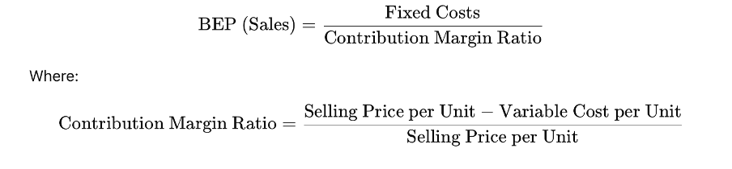

    - Investment Appraisal Ratios
These ratios help in evaluating the profitability and potential return from an investment
- Payback Period

The payback period is the period required to recover the cost of an investment. It helps in determining whether to undertake a project or not, as shorter the payback period more desirable the project becomes.

The formula to calculate payback period of a project depends on whether the cash flow per period from the project is even or uneven.

In case they are even, the formula to calculate payback period is:

$$Payback Period=\frac{Initial Investment}{Cash Flow}$$

When cash inflows are uneven, calculate the cumulative net cash flow for each period and then use the following formula for payback period:

$$Payback Period=A+\frac{B}{C}$$

Where,
A is the last period with a negative cumulative cash flow
B is the absolute value of cumulative cash flow at the end of the period A
C is the total cash flow during the period after A

- Net Present Value

Net Present Value (NPV) is the value of the future cash flows for the entire project life discounted to the present. When the entrepreneur or investors have several projects to be undertaken, the project with highest NPV is considered the best suited project in general.

The formula for Net Present Value is:

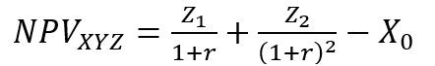
Where:
Z1 = Cash flow in time 1
Z2 = Cash flow in time 2
r = Discount rate
X0 = Cash outflow in time 0 (i.e. the purchase price / initial investment)

Decision rule:

Accept the project if NPV> 0 (indicates the project adds value)
Reject if NPV<0 (indicates the project destroys value)

- Internal Rate of Return

The discount rate that makes the NPV of all cash flows from a particular project equal to zero. A higher IRR indicates a more profitable investment.
Formula:

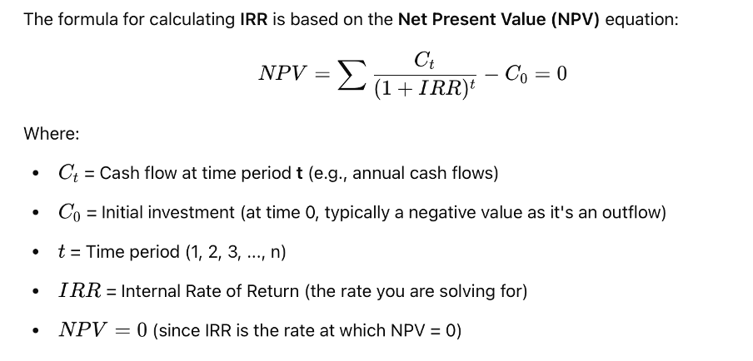
Decision rule:

Accept if IRR is >Required Rate of Return (Cost of Capital)
Reject if IRR is < Required Rate of Return (Cost of Capital)
    - Efficiency Ratio
The Efficiency Ratio is a financial metric that measures how well a company uses its assets and liabilities to generate sales and profits. A higher efficiency indicates effective utilization of its resources. Efficiency ratios are important to assess the efficiency of a business in running its operations, including the use of assets and managing cost.

- Asset Turnover Ratio

The Asset Turnover Ratio measures how effectively a business uses its assets to generate revenue. A higher ratio indicates better utilization of assets.

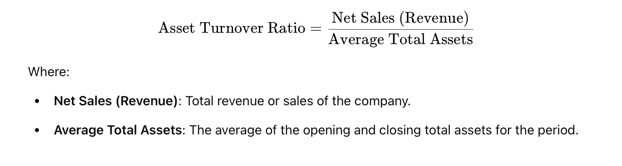
Where:
Net Sales (Revenue) Total revenue of sales of the company
Average Total Assets The average of the opening and closing total assets for the period
- Inventory Turnover Ratio

The Inventory Turnover Ratio shows how many times a business sells and replaces its inventory over a period. A high turnover rate is considered favourable, which indicates efficient inventory management.

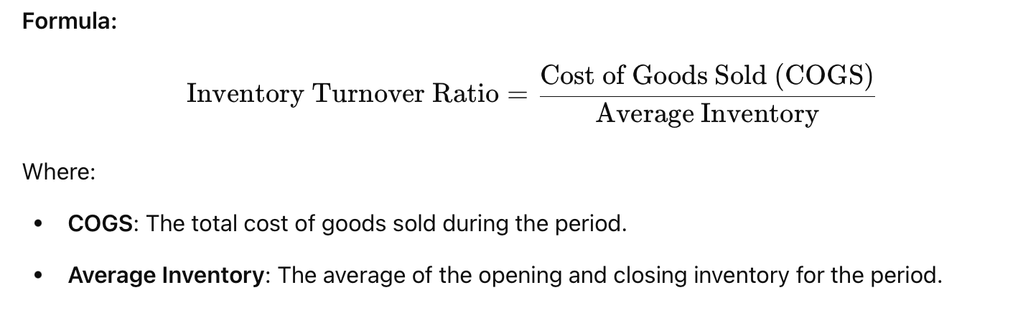

Where:
COGS The total cost of goods sold during the period.
Average Inventory The average of the opening and closing inventory for the period

- Employee Efficiency Ratio

The Employee Efficiency Ratio measures how much revenue is generated per employee, helping assess workforce productivity.

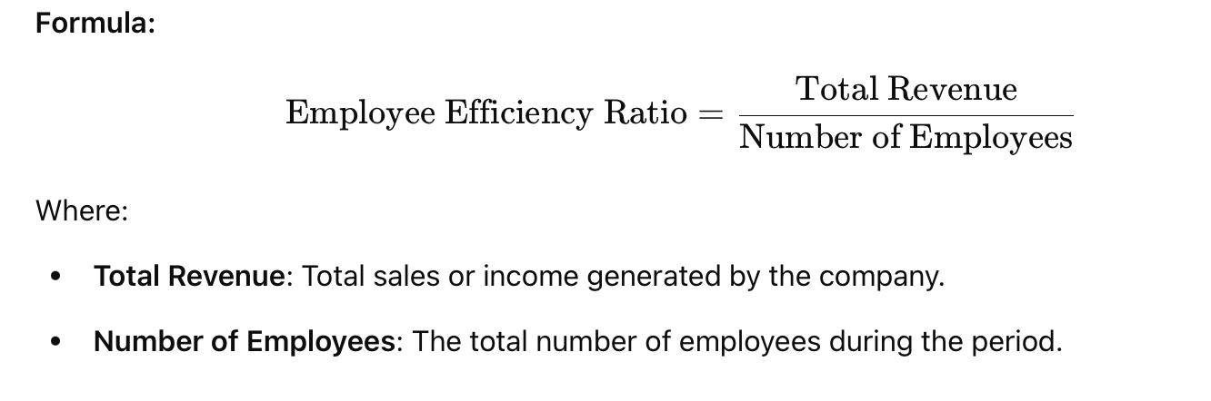
Where:
Total Revenue Total sales or income generated by the company
Number of Employees The total number of employees during the period

    - Solvency Ratio
The Solvency Ratio measures a company's ability to meet its long-term debt obligations. It is important for investors and creditors to understand a company’s financial health and its capacity to handle its liabilities in the long term. A higher solvency ratio indicates better financial stability, while a lower ratio suggests higher financial risk.

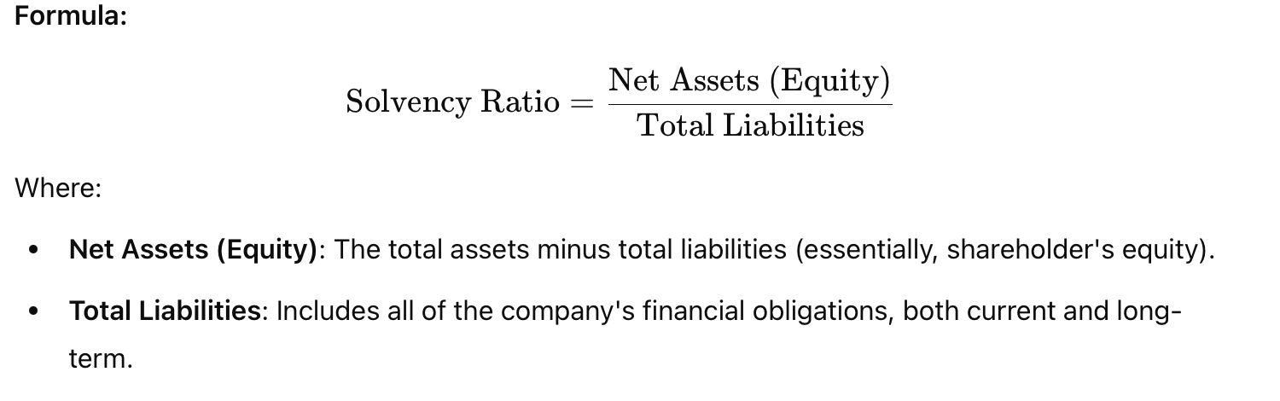

Decision rule:
A higher ratio indicates a strong solvency position, meaning the company has a good buffer to absorb its liabilities.
A lower ratio suggests the company may struggle to meet its obligations and might be at risk of insolvency.

- Debt to Equity Ratio

The Debt-to-Equity Ratio compares a company’s total liabilities to its shareholder equity. It provides insight into the level of financial leverage being used by a company. A high ratio indicates that the company is relying heavily on debt to finance its operations, which m​​ay increase financial risk.
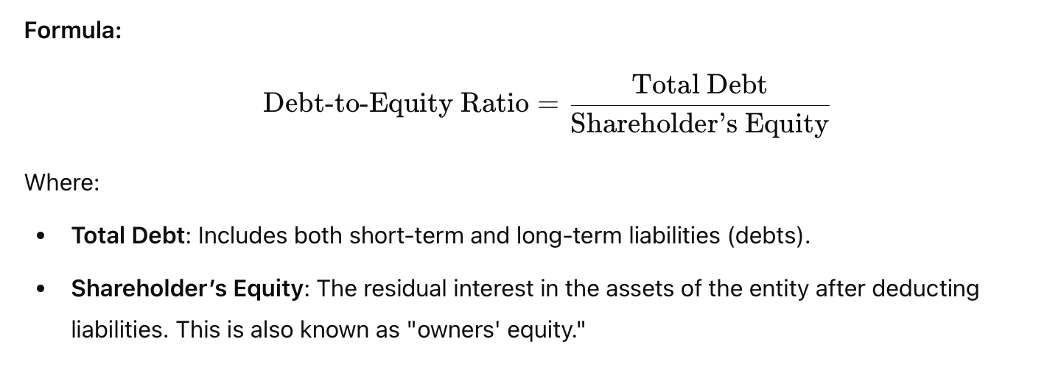
Decision rule:
A higher ratio (e.g., greater than 1) suggests that the company is highly leveraged and may be riskier.
lower ratio (e.g., less than 1) indicates the company is less reliant on debt, which generally makes it less risky.

    - Liquidity Ratio
A liquidity ratio is a financial metric used to measure a company's ability to meet its short-term obligations (debts or liabilities) using its short-term assets. It helps assess whether a company has enough liquid assets to cover its immediate liabilities without requiring additional financing or selling long-term assets.

- Current ratio

Indicates how well a company can pay its short-term liabilities with its short-term assets. A ratio above 1 typically suggests good liquidity.
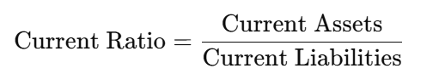

- Quick ratio (Acid test ratio)

Excludes inventory from current assets as it may not be quickly convertible to cash. It provides a more stringent test of liquidity.
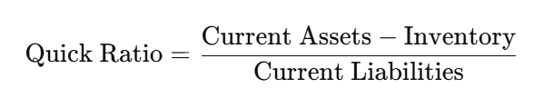

- Cash ratio

Focuses only on the most liquid assets (cash and equivalents) to determine immediate solvency.


    - Profitability Ratios
A profitability ratio is a financial metric used to assess a company's ability to generate profits relative to its revenue, assets, equity, or other financial components. These ratios help evaluate how efficiently a company utilizes its resources to produce earnings.

- Profit margin

Profit margin is a commonly accepted measure of profitability. The relationship of profit to sales indicates the entrepreneur’s ability to operate the business with sufficient success not only to recover all costs from revenues for the period but also to leave a margin of reasonable compensation to him/her for providing his/her capital at risk. It essentially expresses the cost/price effectiveness of the business operation. The ratio is also called percentage return on sales, margin on sales or net profit percentage.

$$Profit Margin=\frac{Earnings Before Interest \& Tax}{Sales}*100$$

- Return on Investment (ROI)
ROI is a method of calculating the profitability of business. It determines how much money can be made on the investment as a percentage of the cost of investment. ROI can be calculated using the formula:
$$ROI=\frac{Earnings Before Interest \& Tax}{Initial Investment}*100$$

- Return on Equity (ROE)
Shows the return generated on shareholders' investments. It helps investors assess how well their capital is being managed.
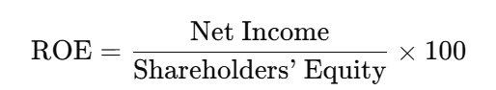

    - Financial Assumptions

Financial assumptions
State assumptions made in arriving at the financial plan. It is important to make realistic assumptions, by considering the practice in credit sales, cash sales, credit terms and many other financial practices adopted in the area and in your industry.
Assumption 1
....................................................................................…….............................................................……………...................................................................…………..........…………
Assumption 2
....................................................................................……................................................................................……………...........................................................…………………...
Assumption 3
....................................................................................……...................................................................................................…………….......................................……………………
Assumption 4
....................................................................................…….....................................................................................................................…………….....................………………………..

Bibliography
- Breuer, H. & Lüdeke-Freund, F. (2014). Normative Innovation for Sustainable Business Models in Value Networks, The Proceedings of XXV ISPIM Con- ference – Innovation for Sustainable Economy and Society, 8-11 June 2014, Dublin, Ireland.
- British Columbia Institute of Technology Student Association (BCITSA). (n.d.) The Idea Evaluation Matrix. The Entrepreneurial Services.

Annexure

Depreciation Schedule

Depreciation Schedule as per the Rules on the Income Tax Act of the Kingdom of Bhutan 2001
Block | Sl. No. | Asset Type | Maximum Rates
I | INFRASTRUCTURAL FACILITIES
 | 1 | Building – Permanent – All types | 3%
 | 2 | Bridges – Permanent | 3%
 | 3 | Compound Walls and Fencing | 3%
 | 4 | Roads – Permanent | 3%
 | 5 | Tube Wells and Deep Wells and Water Pipe Lines | 3%
 | 1 | Semi-Permanent | 20%
 | 2 | Temporary | 50-100%
II | ELECTRICITY GENERATION AND TRANSMISSION
 | 1 | Devices for controlling transmission loss | 5%
 | 2 | Generator (Hydro) | 5%
 | 3 | Power House Equipment | 5%
 | 4 | Poles and Pillars | 5%
 | 5 | Substation Equipment | 5%
 | 6 | Transmission Lines – HT & LT | 5%
 | 7 | Underground Cables | 5%
III | EQUIPMENT
 | 1 | Audio/Visual Equipment | 15%
 | 2 | Computer/Data Processing System | 15%
 | 3 | Deep Freezers / Refrigerators (Hotels & General Use) | 15%
 | 4 | Fire Fighting Equipment/System | 15%
 | 5 | Lightning Arresters | 15%
 | 6 | Laboratory Equipment | 15%
 | 7 | LPG Cylinders | 15%
 | 8 | Office Equipment – all types | 15%
 | 9 | Photographic/Reprographic Equipment | 15%
 | 10 | Pollution Control Equipment | 15%
 | 11 | Telephone including PABX system | 15%
 | 12 | Tools and Implements | 15%
 | 13 | Trekking Equipment | 15%
 | 14 | Vaccum Cleaner | 15%
 | 15 | Water Cooler and Water Purifier | 15%
 | 16 | Weighing Machines | 15%
 | 17 | Washing Machines | 15%
IV | FURNITURE, FIXTURES AND UTENSILS
 | 1 | Ceramic and Glass Utensils | 15%
 | 2 | Carpets of all types | 15%
 | 3 | Curtains & Heavy Drapes | 15%
 | 4 | Domestic Electrical Appliances and Fixtures | 15%
 | 5 | Furniture of all Kinds | 15%
 | 6 | Mattresses, Pillows and Blankets | 15%
 | 7 | Silver, Steel and Metallic Crockeries | 15%
V | PLANT & MACHINERY (including spare parts and accessories)
 | 1 | Boilers | 15%
 | 2 | Cinema Projectors and Screen | 15%
 | 3 | Cranes, Chain and Pulley | 15%
 | 4 | Deep Freezers / Refrigerators (Industrial Purposes) | 15%
 | 5 | Earth Moving Machinery including Bulldozers | 15%
 | 6 | Scrapers, Excavators, Wheel Loaders, etc. | 15%
 | 7 | Fork Lifts | 15%
 | 8 | Industrial Gas Cylinders | 15%
 | 9 | Lifts | 15%
 | 10 | Mining Equipment and Machineries | 15%
 | 11 | Petrol Pump Installation and Tanks | 15%
 | 12 | Printing Machineries | 15%
 | 13 | Rope Way Installation | 15%
 | 14 | Road Rollers | 15%
 | 15 | Railing & Locomotives’ Storage Tanks | 15%
 | 16 | Wood Cutting / Processing Machines | 15%
VI | VEHICLES, VESSELS AND AIRCRAFTS
 | 1 | Aircraft including Helicopter | 15%
 | 2 | Buses & Vans | 15%
 | 3 | Cycles & Rickshaws | 15%
 | 4 | Light Motor Vehicles including two or three Wheelers | 15%
 | 5 | Trucks & Trailers | 15%
 | 6 | Vessels – Ships, Boats, Rafts, etc.
VII | SMALL ASSETS costing up to Nu.25,000 in total per tax payer per income year |  | Write off

Contracts or agreements

Lagthram

Other Evident Documents

[IMPORTANT INSTRUCTIONS]

Business Plan- Typing Format
1. Major Headings
- Font type Tahoma 12, bold
- Left justified, mixed case with major words capitalized and bold with one line above and one line below the heading to separate it from the text.
2. The Second Heading Level
- Italicized with the major words capitalized.
- The paragraph is indented five spaces, or half inch on the left.
3. The Third Heading Level
- Indented, italicized and major words capitalized.
4. Text in Sections
- Font type Tahoma 11
- The first paragraph is not indented.
- Do not space between paragraphs within a section.

